FIRST AID POLICY
To be read in conjunction with:
MPPS Accidents, Injuries and First Aid Reporting Policy
MPPS Anaphylaxis Management Policy
Rationale:
All children have the right to feel safe and well, and know that they will be attended to with due care when in need of first aid. The Care Arrangements are to be read in conjunction with the Moonee Ponds Primary School First Aid Policy which outlines the schools’s responsibility and procedures in respect of our “responsibility to provide equitable access to education and respond to diverse student needs, including health care needs”.

Aims:
- To ensure all teachers assume responsibility for student care and that they are confident, skilled and proactive in the management of student health issues and able to respond to individual students.
- To develop processes and protocols that are clear and well known to ensure the effectiveness of student care arrangements for ill students and students with medical conditions.
- To ensure the school community understands our school’s approach to first aid for students.

Our school will:
- administer first aid to children when in need in a competent and timely manner.
- communicate children’s health problems to parents when considered necessary.
- provide supplies and facilities to cater for the administering of first aid.
- maintain a sufficient number of staff members trained with a level 2 first aid certificate.

Implementation:
From time to time Moonee Ponds Primary School staff might need to administer first aid to students at school or school activities.
Parents/carers should be aware that the goal of first aid is not to diagnose or treat a condition

First aid provision
- A sufficient number of staff (including at least 1 administration staff member) to be trained to a level 2 first aid certificate, and with up-to-date CPR qualifications.
- A register of all first aid trained staff will updated each year with the list of Moonee Ponds Primary Schools first aid officers and date of completed training.
- A first aid room will be available for use at all times. A comprehensive supply of basic first aid materials will be stored in a locked cupboard in the first aid room.
- First aid kits will also be available in the staff room, PE storeroom, science room and administration office.
- A supply of medication for teachers will be available in a locked drawer in the administration office.
- A member of staff is to be responsible for the purchase and maintenance of first aid supplies, first aid kits, ice packs and the general upkeep of the first aid room.

Staff Training
- All staff will be provided with basic first aid management skills, including blood spills, and a supply of protective disposable gloves will be available for use by staff.

Supervision
- Supervision of the first aid room will be managed by the administration staff.
- All injuries or illnesses that occur during class time will be referred to the administration staff through a written notification (See Appendix 1) who will manage the incident.
- All injuries or illnesses that occur during recess or lunch breaks will be referred to the teacher on yard duty. If further assistance is needed, the student will be referred to the administration staff who will assist them or direct them to the staff room.

Record keeping
- A confidential up-to-date register (kept under lock and key) located in the administration office will be kept of all injuries or illnesses experienced by children that require first aid.

Care for ill students
- Students who are unwell should not attend school.
- If a student becomes unwell during the school day they may be directed to the first aid room and monitored by staff. Depending on the nature of their symptoms, staff may contact parents/carers or an emergency contact person to ask them to collect the student.

First aid management
If there is a situation or incident which occurs at school or a school activity which requires first aid to be administered to a student:
- Staff who have been trained in first aid will administer first aid in accordance with their training. In an emergency situation, other staff may assist in the administration of first aid within their level of competence. Minor injuries will be treated by staff members on duty, while more serious injuries-including those requiring parents to be notified or suspected treatment by a doctor - require a level 2 first aid trained staff member to provide first aid.
- In a medical emergency, staff may take emergency action and do not need to obtain parent/carer consent to do so. Staff may contact Triple Zero “000” for emergency medical services at any time.
- Staff may also contact NURSE-ON-CALL (on 1300 60 60 24) in an emergency. NURSE-ON-CALL provides immediate, expert health advice from a registered nurse and is available 24 hours a day, 7 days a week.
- Any children with injuries involving blood must have the wound covered at all times.
- In accordance with guidance from the Department of Education and Training, analgesics, including paracetamol and aspirin, will not be stored at school or provided as a standard first aid treatment. This is because they can mask signs of serious illness or injury.
- No medication including headache tablets will be administered to children without the express written permission of parents or guardians.

Communication
- At the commencement of each year, requests for updated first aid information will be sent home including requests for any asthma, diabetes and anaphylaxis management plans, high priority medical forms, and reminders to parents of the policies and practices used by the school to manage first aid, illnesses and medications throughout the year.
- Parents of all children who receive first aid for injuries other than minor cuts and abrasions will receive a completed form indicating the nature of the injury, any treatment given, and the name of the teacher providing the first aid. For more serious injuries/illnesses, the parents/guardians must be contacted by the administration staff so that professional treatment may be organised. Any injuries to a child’s head, face, neck or back must be reported to parents/guardian.
- Any student who is collected from school by parents/guardians as a result of an injury, or who is administered treatment by a doctor/hospital or ambulance officer as a result of an injury, or has an injury to the head, face, neck or back, or where a teacher considers the injury to be greater than “minor” will be reported on Department of Education Accident/Injury form LE375 (See MPPS Accidents, Incidents & First Aid Reporting Policy), and entered onto CASES.
- Parents of ill children will be contacted to take the children home.
- Parents who collect children from school for any reason (other than emergency) must sign the child out of the school in a register maintained in the school office.
- All teachers have the authority to call an ambulance immediately in an emergency. If the situation and time permit, a teacher may confer with others before deciding on an appropriate course of action. If first aid is administered for a serious injury or condition, or in an emergency situation, school staff will attempt to contact parents/carers or emergency contacts as soon as reasonably practical.
- If staff providing first aid determine that an emergency response is not required but that medical advice is needed, school staff will ask parents/carers, or an emergency contact person, to collect the student and recommend that advice is sought from a medical practitioner.
- General organisational matters relating to first aid will be communicated to staff at the beginning of each year. Revisions of recommended procedures for administering asthma, diabetes and anaphylaxis medication will also be given at that time.

Camps, Excursions and First aid
- All school camps will have at least 1 Level 2 first aid trained staff member at all times.
- A comprehensive first aid kit will accompany all camps, along with a mobile phone.
- All children attending camps or excursions will have provided a signed medical form providing medical detail and giving teachers permission to contact a doctor or ambulance should instances arise where their child requires treatment. Copies of the signed medical forms to be taken on camps and excursions, as well as kept at school.
- All children, especially those with a documented asthma management plan, will have access to Ventolin and a spacer at all times.
- It is recommended that all students have personal accident insurance and ambulance cover.

The attached Example templates (Diabetes/Epilepsy) are also to be read in conjunction with the Department of Education and Training School Policy & Advisory Guide: Student Health, which outlines the school’s responsibility and procedures in respect of our “responsibility to provide equitable access to education and respond to diverse student needs, including health care needs”.

Confidential records of all students with specific health needs are maintained securely in the general office for reference as required. Staff also receive a list of students with medical conditions at the commencement of the year that they keep secure with their attendance notes/roll.

References:
Department of Education and Training School Policy & Advisory Guide: Student Health | http://www.education.vic.gov.au/school/principals/spag/health/Pages/supportplanning.aspx

Appendices
- Procedures for using the First Aid Room (template)
- Asthma Care Plan for Education and Care Services form
- Condition Specific Medical Advice Form for a student with Diabetes
- Condition Specific Medical Advice Form for a student with Epilepsy and seizures

Evaluation:
This policy will be evaluated on a 4 year review cycle.
Key Person responsible for development of the Policy: Principal

This policy was last ratified by School Council in....

Appendix 1

PROCEDURES FOR USING:
THE SICK BAY/FIRST AID ROOM
THIS DOCUMENT TO BE PLACED IN STUDENT’S FILE

1. Teacher signs proforma (see below)

2. Student takes proforma to the office.
(Have someone wait with him/her)

3. Office staff make arrangements -
* ensure student goes into sick bay.
* advise homegroup teacher if student has come from a specialist class.

- Students are not to help themselves to First Aid supplies.

- Contact Parent/guardian if student needs to go home.

Matt Bott
Principal

is feeling unwell/has been hurt and will need -

Action Taken
to go home Ice-Pak

- First Aid treatment Medication/Bandaids

- To go to Sick Bay Parent contacted …………..

Temporary stay & review

Signed: Teacher:
Date: Time:

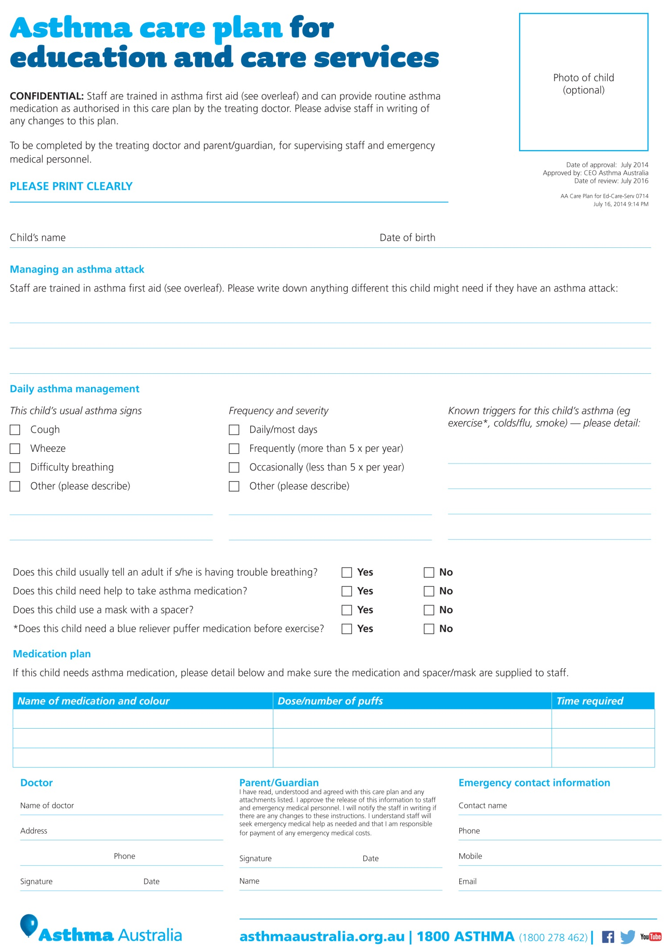
Appendix 2

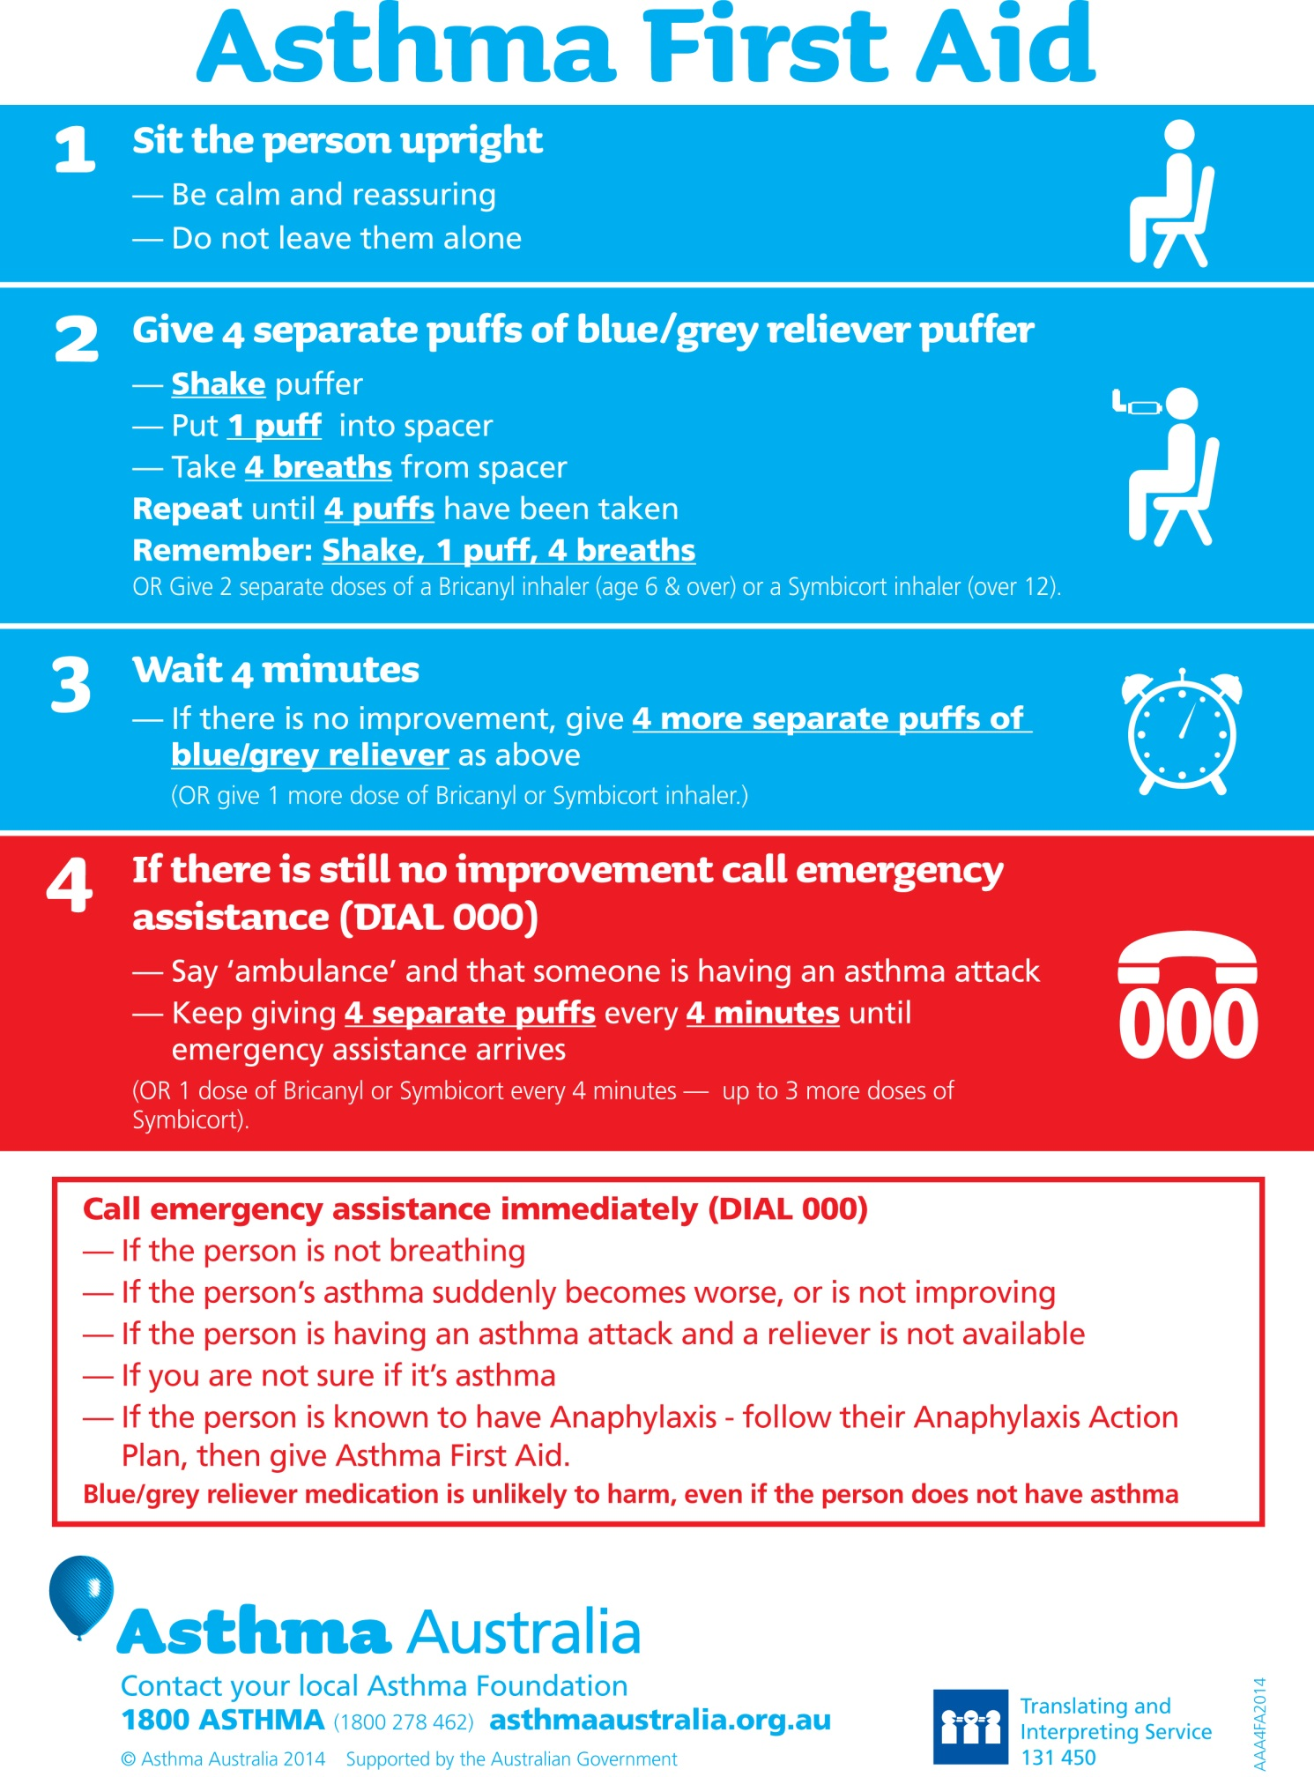
Appendix 3
Condition Specific Medical Advice Form
for a student with Diabetes
This form is to be completed by the student’s medical/health practitioner providing a description of the health condition and first aid requirements for a student with a health condition. This form will assist the school in developing a Student Health Support Plan which outlines how the school will support the student’s health care needs.

Name of School:
Student’s Name:_______________________________________ Date of Birth:_____________
MedicAlert Number(if relevant): _________________ Review date for this form: _________
Description of the condition | Recommended support  Please describe recommended care  If additional advice is required, please attach it to this medical advice form
Diabetes Management
Please provide relevant details in relation to the student’s Diabetes management.
Student self management
Is this student usually able to self manage their own diabetes care?
Yes
No
If no, please provide details in relation to how the school should support the student in developing self-management.

Relevant issues
Please outline any relevant issues in relation to attendance at school and learning as well as support required at school.

First Aid – Signs of Hypoglycaemia (low blood glucose)
Below is a list of observable signs that school staff will look for in relation to a hypoglycaemia. Please provide comment, if required.

Mild signs: sweating, paleness, trembling, hunger, weakness, changes in mood and behaviour (e.g. crying, argumentative outbursts, aggressiveness), inability to think clearly, lack of coordination

Moderate signs: inability to help oneself, glazed expression, being disorientated, unaware or seemingly intoxicated, inability to drink and swallow without much encouragement, headache, abdominal pain or nausea.

Severe signs: inability to stand, inability to respond to instructions, extreme disorientation, inability to drink and swallow (leading to danger of inhaling food into lungs), unconsciousness or seizures (jerking or twitching of face, body or limbs)

First Aid – Hypoglycaemia
The following is the first aid response that School staff will follow:

Observable sign/reaction |  | First aid response
Mild / Moderate Hypoglycaemia signs |  |  | Give glucose immediately to raise blood glucose (e.g. half a can of ‘normal’ soft drink or fruit drink (with sugar), or 5 – 6 jelly beans.)
 |  |  | Wait and monitor for 5 minutes.
Mild / Moderate Hypoglycaemia signs |  |  | If there is no improvement, repeat giving glucose (e.g. half a can of ‘normal’ soft drink or fruit drink (with sugar), or 5 – 6 jelly beans.)
 |  |  | If the student’s condition improves, follow up with a snack of one piece of fruit, a slice of bread or dried biscuits only when recovered.
Severe Hypoglycaemia signs |  |  | If there is still no improvement to the student’s condition, call an ambulance. State clearly that the person has diabetes, and whether he or she is conscious. Inform emergency contacts.
Severe Hypoglycaemia signs |  |  | If unconscious, maintain Airway, Breathing and Circulation while waiting for the ambulance.  Never put food/drink in mouth of person who is unconscious or convulsing. The only treatment is an injection of glucoses into the vein (given by doctor/paramedic) or an injection of Glucagon.

First Aid– Hypoglycaemia
If you anticipate the student will require anything other the first aid response noted above, please provide details, so special arrangement can be negotiated.

Observable sign/reaction |  | First aid response

Description of the condition | Recommended support  Please describe recommended care  If additional advice is required, please attach it to this medical advice form
First Aid – Signs of Hyperglycaemia (High blood glucose)
Below is a list of observable signs that school staff will look for in relation to Hyperglycaemia. Please provide comment, if required.

Sings for this condition will emerge over two or three days and can include:
- frequent urination
- excessive thirst
- weight loss
- lethargy
- change in behavior
First Aid Response– Hyperglycaemia (High blood glucose)
The school will provide a standard first aid response and will call an ambulance if any of the following is observed or reported:
- Rapid, laboured breathing
- Flushed cheeks
- Abdominal pains
- Sweet acetone smell to the breath
- Vomiting
- Severe dehydration.

Please provide comment, if required.
Privacy Statement
The school collects personal information so as the school can plan and support the health care needs of the student. Without the provision of this information the quality of the health support provided may be affected. The information may be disclosed to relevant school staff and appropriate medical personnel, including those engaged in providing health support as well as emergency personnel, where appropriate, or where authorised or required by another law. You are able to request access to the personal information that we hold about you/your child and to request that it be corrected. Please contact the school directly or FOI Unit on 96372670.
Authorisation:
Name of Medical/health practitioner:
Professional Role:
Signature:

Date:
Contact details:

Name of Parent/Carer or adult/independent student**:
Signature:

Date:
If additional advice is required, please attach it to this form
**Please note: Adult student is a student who is eighteen years of age and older. Independent student is a student under the age of eighteen years and living separately and independently from parents/guardians (See Victorian Government Schools Reference Guide 4.6.14.5).

Appendix 4
Condition Specific Medical Advice Form
for a student with Epilepsy and seizures

This form is to be completed by the student’s medical/health practitioner providing a description of the health condition and first aid requirements for a student with a health condition. This form will assist the school in developing a Student Health Support Plan which outlines how the school will support the student’s health care needs.
Name of School:
Student’s Name:_________________________________Date of Birth:____________ _
MedicAlert Number(if relevant): ___________ Review date for this form:
Description of the condition |  |  | Recommended support  Please describe recommended care  If additional advice is required, please attach it to this medical advice form
Warning Signs
Can you please outline the warning signs (e.g. sensations)

Triggers
Can you please outline the known triggers (eg illness, elevated temperature, flashing lights)
Seizure Types
Please highlight which seizure types apply: |  |  | Please indicate typical seizure frequency and length, and any management that is a variation from standard seizure management.
Partial (focal) seizures | Which side of the brain is affected?  _____________________________________________
  Simple partial
 Staring, may blink rapidly
 Only part of the brain is involved (partial)
 Person remains conscious (simple), able to hear, may or may not be able to speak
 Jerking of parts of the body may occur
 Rapid recovery
 Person may have a headache or experience sensations that aren’t real, such as sounds, flashing light, strange taste or smell, ‘funny tummy’ These are sometimes called an aura and may lead to other types of seizures.
  Complex partial
 Only part of the brain is involved (partial)
 Person staring and unaware. Eyes may jerk but may talk, remain sitting or walk around
 Toward the end of the seizure, person may perform unusual activities, eg chewing movement, fiddling with clothes (these are called automatisms)
 Confused and drowsy after seizure settles, may sleep.
Generalised seizures
  Tonic clonic   Not responsive   Might fall down/cry out   Body becomes stiff (tonic)   Jerking of arms and legs occurs (clonic)   Excessive saliva |  |  May be red or blue in the face   May lose control of bladder and/or bowel   Tongue may be bitten   Lasts 1-3 minutes, stops suddenly or gradually   Confusion and deep sleep (maybe hours) when in recovery phase. May have a headache.
  Absence
 Vacant stare or eyes may blink/roll up
   Lasts 5-10 seconds
   Impaired awareness (may be seated)
 Instant recovery, no memory of the event.
  Myoclonic
 Sudden simple jerk
   May recur many times.

Duration
How long does recovery take if the seizure isn’t long enough to require Midazolam?

Person’s reaction during and after a seizure
Please comment

Any other recommendations to support the person during and after a seizure
Signs that the seizure is starting to settle
First Aid - Management of Seizures
The following is the first aid response that School staff will follow:
(Developed by Children’s Epilepsy Program, Royal Children’s Hospital)
:

 | "Major Seizures" | "Minor Seizures"
 | Convulsive seizures with major movement manifestations  eg: tonic-clonic, tonic, myoclonic, atonic, and partial motor seizure | Seizures with staring, impaired consciousness or unusual behaviour e.g. complex partial seizures and absence seizures
1 | Stay calm | Stay calm
2 | Check for medical identification | Check for medical identification
3 | Protect the person from injury by removing harmful objects close to them. Loosen any tight clothing or restraints. Place something soft under their head. | Protect the person from injury by removing harmful objects close to them
4 | Stay with the person and reassure them. Do not put anything in their mouth and do not restrain them. | Stay with the person and reassure them
5 | Time the seizure | Time the seizure
6 | When the seizure is over, roll the person onto their side to keep their airway clear | If a tonic-clonic seizure develops, follow major seizure management
7 | Treat any injuries | Stay with the person and reassure them, they may be sleepy, confused or combative after the seizure
8 | Consider if an ambulance needs to be called. An ambulance should be called when:  - The seizure lasts longer than 5 -10 minutes.  - Another seizure quickly follows  - The person remains unconscious after the seizures ceases  - The person has been injured  - You are about to administer diazepam or midazolam  - You are unsure  - The seizure happens in water  - The person is pregnant or a diabetic  - The person is not known to have epilepsy.
9 | Stay with the person and reassure them, they may be sleepy, confused or combative after the seizure

First Aid - Management of Seizures
If you anticipate the student will require anything other the first aid response noted above, please provide details, so special arrangement can be negotiated.

Observable sign/reaction |  | First aid response

Privacy Statement
The school collects personal information so as the school can plan and support the health care needs of the student. Without the provision of this information the quality of the health support provided may be affected. The information may be disclosed to relevant school staff and appropriate medical personnel, including those engaged in providing health support as well as emergency personnel, where appropriate, or where authorised or required by another law. You are able to request access to the personal information that we hold about you/your child and to request that it be corrected. Please contact the school directly or FOI Unit on 96372670.

Authorisation:
Name of Medical/health practitioner:
Professional Role:
Signature:
Date:
Contact details:

Name of Parent/Carer or adult/independent student**:
Signature:
Date:
If additional advice is required, please attach it to this form
**Please note: Adult student is a student who is eighteen years of age and older. Independent student is a student under the age of eighteen years and living separately and independently from parents/guardians (See Victorian Government Schools Reference Guide 4.6.14.5)

