YARD DUTY AND SUPERVISION POLICY

Rationale:
Adequate supervision of students in the school yard is a requirement of the school’s duty of care. The school will usually satisfy the duty of care for the on-site management of students, outside normal timetabled class time, by allocating responsibilities for supervision to different staff. The principal or nominee is responsible for making and administering such arrangements for supervision as are necessary according to the circumstances in the school, and teachers are responsible for carrying out their assigned supervisory duties in such a way that students are, as far as can be reasonably expected, protected from injury.

Aims:
- To ensure school staff understand their supervision and yard duty responsibilities.
- To ensure all teachers assume responsibility for student care and that they are confident, skilled and proactive in the management of student safety.
- To develop processes and protocols that are clear and well known to ensure the effectiveness of student care arrangements for student safety.

Scope
The principal is responsible for ensuring that there is a well-organised and responsive system of supervision in place during school hours, before and after school, and on school excursions and camps.
This policy applies to all teaching and non-teaching staff at Moonee Ponds Primary School, including education support staff, casual relief teachers and visiting teachers.
School staff are responsible for following reasonable and lawful instructions from the principal, including instructions to provide supervision to students at specific dates, time and places.

Implementation:

GUIDELINES
- As part of its duty of care the school is required to adequately supervise students for a defined period before school; at recess time and lunch time; and after school.
- This on-site supervision requires not only protection from known hazards, but also protection from those that could arise (that is, those the teacher should reasonably have foreseen) and against which preventive measures could be taken.
- Parents/carers are informed as to when supervision of students is available before and after school, and that outside these times supervision and/or the collection of students is the responsibility of parents/carers.
- Parents/carers are discouraged from sending their children to school before the designated supervision time in the morning, unless they are attending the Out of School Hours Care (OSHC) program. Parents/carers are encouraged to pick up their child by the end of the designated end of day supervision period, unless they are attending the OSHC program. This information should be clearly provided to parents/guardians on a regular basis, via the school newsletter, website, or Parent Information booklets or sessions.
- Although children are expected to attend school daily, there may be times when parents/carers require their child to leave the school grounds to:
  - go home for a particular reason
  - be dismissed early from school to attend an appointment.
Parents should record these requests in writing to the class teacher and/or principal.
- The school has a process to authorize these requests and maintain accurate records of student attendance.

PROCEDURES
A roster system will be used to timetable staff members for yard supervision. Yard supervision will include before school, recess and lunch breaks, and after school.

The supervision of the arrival and departure of any school contract buses used for excursions and camps will be the responsibility of the teachers supervising that activity.

Supervision before and after school
The school will provide staff supervision for students arriving before school between 8.45am and 9.00am. The school will also provide staff supervision for students after school between 3.20pm and 3.35pm. Both these sessions conclude with the school bell. Sufficient teachers will be allocated by the school principal or their nominee to supervise students during these periods. This information is provided to parents/guardians on a regular basis via the school newsletter. Outside of these times the supervision and/or the collection of students is the responsibility of parents/guardians.

Should a teacher be called away to other duties, alternate supervision arrangements will be put in place in consultation with the principal or their nominee.

Sufficient teachers will be allocated by the school principal or their nominee to supervise students during these periods.

Should a teacher be called away to other duties alternate supervision arrangements will be put in place in consultation with the principal or their nominee.

If a student arrives at school before supervision commences at the beginning of the day, the principal or nominee staff member will, as soon as practicable, follow up with the parent/carer to:
- advise of the supervision arrangements before school
- request that the parent/carer make alternate arrangements.

Arrangements for students not collected after school
Students remaining in the school yard awaiting collection after 3:35pm will be directed to the office waiting area (after the school bell).

If it becomes known that a student who is normally collected from the school, remains at the school well beyond the normal time of collection, attempts will be made to contact the parents/guardians, or the emergency contact person identified by the parent/guardian in the school records. In order to provide supervision for an uncollected student, s/he may be taken to the Out of School Hours Care (OSHC) program and the cost for this is the parent/carer’s responsibility.

Where all reasonable attempts have been made to locate the parents/guardian and the emergency contact persons, and the time is well beyond a reasonable time for collection, consideration will be given to contacting the police or the Department of Human Services to arrange for the care and protection of the student.

Information about the whereabouts of the student will be left with appropriate friends of the student, or neighbours, if known, and at the school.

Yard Duty & Supervision at recesses and lunch time
Students are required to be adequately supervised during recesses and lunch times.

In order to ensure that students are adequately supervised, a ‘Yard Duty Roster’ will be created each term allocating teachers to supervise students in defined areas of the school grounds during these times. Details of the roster are communicated to teachers electronically, in hard copy and via the staff noticeboard.

On days of extreme weather, students will be supervised in classrooms, using a modified duty roster.
There are two designated yard duty areas:
- Area A is all areas East of the basketball court, the breezeway, the oval.
- Area B is all areas West of (and including) the basketball court as well as the play equipment area, the landscaped areas, the BBQ courtyard and around the Junior Building.

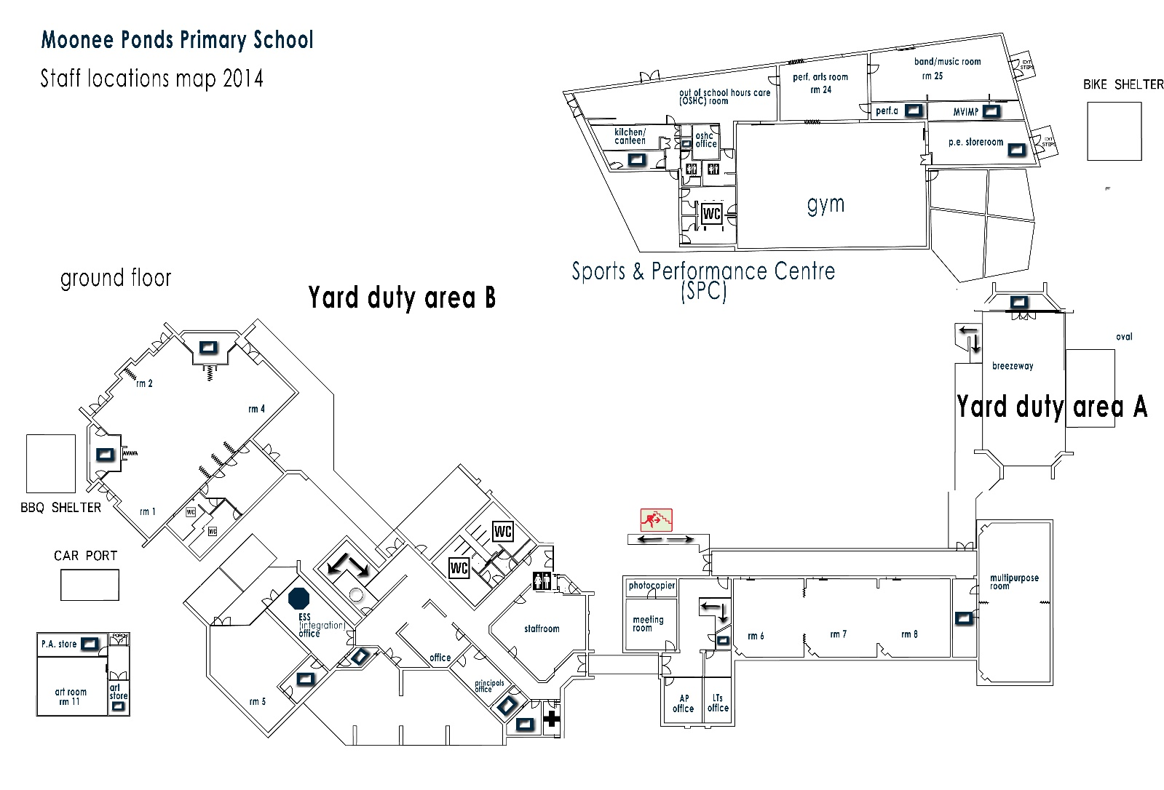
School staff must wear a provided safety/hi-vis vest whilst on yard duty. Safety/hi-vis vests will be stored staff room.

Staff who are rostered for yard duty must remain in the designated area until they are replaced by a relieving teacher.

During yard duty, supervising staff must:
- methodically move around the designated area to ensure that all areas are within line of sight to at least one yard duty teacher at a time.
- be alert and vigilant
- intervene immediately if potentially dangerous or inappropriate behaviour is observed in the yard
- enforce behavioural standards and implement appropriate consequences for breaches of safety rules, in accordance with any relevant disciplinary measures set out in your school’s Student Engagement and Wellbeing policy
- ensure that students who require first aid assistance receive it as soon as practicable
- log any incidents or near misses as appropriate [i.e. incident form, email to class teacher/principal]
- if being relieved of their yard duty shift by another staff member, ensure that a brief but adequate verbal ‘handover’ is given to the next staff member in relation to any issues which may have arisen during the first shift.
If the supervising staff member is unable to conduct yard duty at the designated time, they should contact the Assistant Principal with as much notice as possible prior to the relevant yard duty shift to ensure that alternative arrangements are made. When excursions are organised it is the responsibility of the supervising teacher to swap their yard duty or make alternative arrangements and notify the Assistant Principal.
If the supervising staff member needs to leave yard duty during the allocated time, they should contact the Principal or Assistant Principal but should not leave the designated area until the relieving staff member has arrived in the designated area.
If a relieving or next staff member does not arrive for yard duty, the staff member currently on duty should send a message to the staffroom or office and not leave the designated area until a replacement staff member has arrived. They should also notify the Assistant Principal.
Should students require assistance during recess or lunchtime, they are encouraged to speak to the supervising yard duty staff member. If first-aid treatment (that requires an ice-pack or to be logged in the first-aid record book) is required the student/s will be directed to the First Aid duty teacher in the staffroom (as per First-Aid policy and procedures).
Unauthorised student departure from school
When a student departs from the school (following initial attendance) without authorisation, the parent/guardian will be informed immediately. Where there is reasonable concern for the student’s safety or the safety of others, immediate contact will also be made with the police and the Department’s Emergency and Security Management Branch, telephone 1800 126 126 (24 hour service).

Early departure of students prior to dismissal time
Students must be signed out of the school if departing prior to dismissal time. A record of early departures is kept in the Administration Office and completed for all students departing the school early. Details will include the student’s name, homegroup, the time of departure and the name of the person collecting the student.
- No parents/carers are permitted to take students directly from the classroom.
- Students can only be collected by a responsible person 16 years and over.
- No students will be sent home on their own outside of normal dismissal time.

Classroom
The classroom teacher is responsible for the supervision of all students in their care during class.
If a teacher needs to leave the classroom unattended at any time during a lesson, they should first contact front office/leadership for assistance. The teacher should then wait until another staff member has arrived at the classroom to supervise the class prior to leaving.
Arrangements for student supervision on school camps and excursions
The principal and leadership team are responsible for ensuring that students are appropriately supervised during all school activities, camps and excursions. Appropriate supervision will be planned for special school activities, camps and excursions on an individual basis, depending on the activities to be undertaken and the level of potential risk involved.

The school will provide supervision ratios in line with the Department’s policy as outlined in the DET School Policy & Advisory Guide, depending on the nature and location of the school activity.

Further Information and Resources
DET Student Supervision & Access guidelines:
http://www.education.vic.gov.au/school/principals/spag/safety/Pages/supervisionaccess.aspx

DET School Policy & Advisory Guide
http://www.education.vic.gov.au/school/principals/spag/Pages/spag.aspx
DET Duty of Care guidelines
https://www.education.vic.gov.au/school/principals/spag/safety/Pages/dutyofcare.aspx

Child Safe Standards
https://www.education.vic.gov.au/school/principals/spag/safety/Pages/childsafestandards.aspx
Visitors in school
https://www.education.vic.gov.au/school/principals/spag/safety/Pages/visitorsinschool.aspx

Evaluation:
This policy will be evaluated on a 4 year review cycle.

Key Person responsible for development of the Policy: Principal

This policy was last ratified by School Council in....

